Faculty of Computing



Database Systems Lab Manual # 08

Sitara Rehman

Sap ID:66454

**TASK#1**

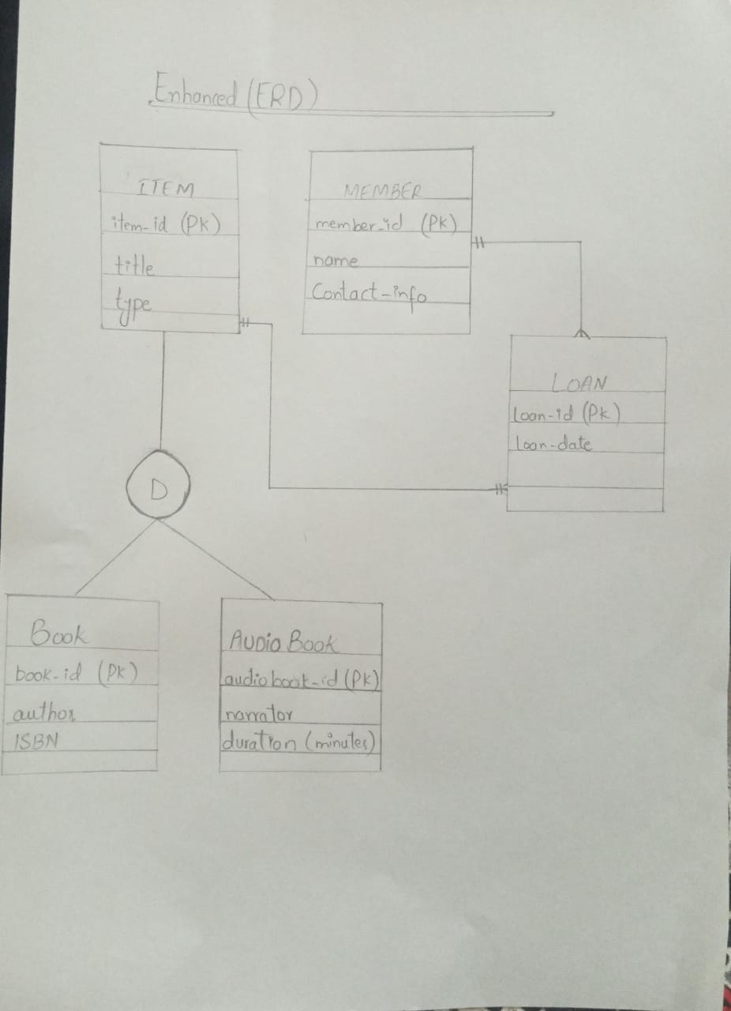

**TASK#2**

CREATING THE DATABASE :

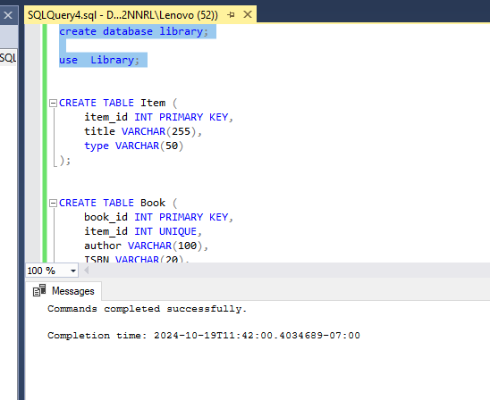

CREATING TABE OF ITEM:

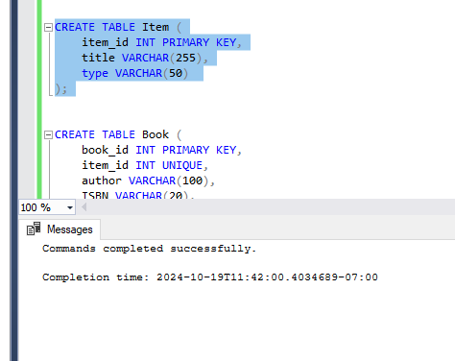

CREATING TABLE OF BOOK:

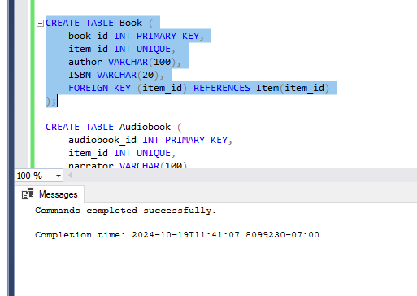

CREATING TABLE OF AUDIOBOOK:

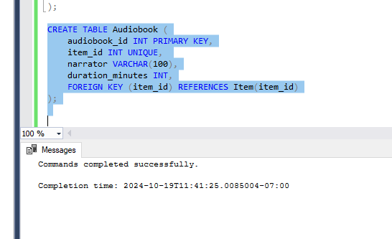

CREATING TABLE OF MEMBER:

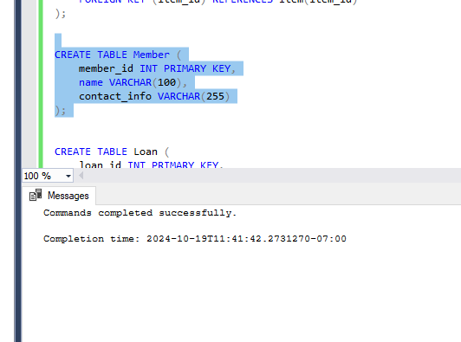

CREATING TABLE OF LOAN:

